AWS Serverless Project

Introduction: As senior engineers at Paradise Donut Company (PDC), you and your team are now well versed in the basic principles of modern software development and systems infrastructure. You know about code repositories, infrastructure as code, deployment pipelines, and now you know about serverless. The company is new to serverless, so you should practice with it in order to prepare for future software development.

Group/Individual: You may do this in a group or as an individual.

The application: The application you are asked to build is a web page that lists a group of related items (donuts, favorite sports characters, favorite video game characters, Coca Cola beverage options--be creative and entertaining) with names and images (see an example below). The item-related information on the web page must be pulled from a database.

As you build this application, consider the infrastructure that would be needed for 31,000 retail locations (if the viewable items were swapped out for donuts in a future iteration of the application).

The item list must come from a database (rather than be static content) because if these were items sold in retail stores, the selection would vary based on the needs/constraints of the individual store.

PDC envisions that this first iteration will be expanded into a full e-commerce website later, so you want to think about how you would smoothly push changes to code and infrastructure into production.

Using existing applications: If you want to use an application that you have worked on for another course or that is part of a personal or work project, you must create everything other than the code itself (i.e. all infrastructure) from scratch: the database, the infrastructure as code, the code pipeline, the use of serverless resources. It can’t be a submission of something that already mostly completes the project. You must be crystal clear on what existed before this current project, and what you added to it. If you didn’t do a comparable amount of work to other individuals or groups, you will be marked down.

Example of main page:
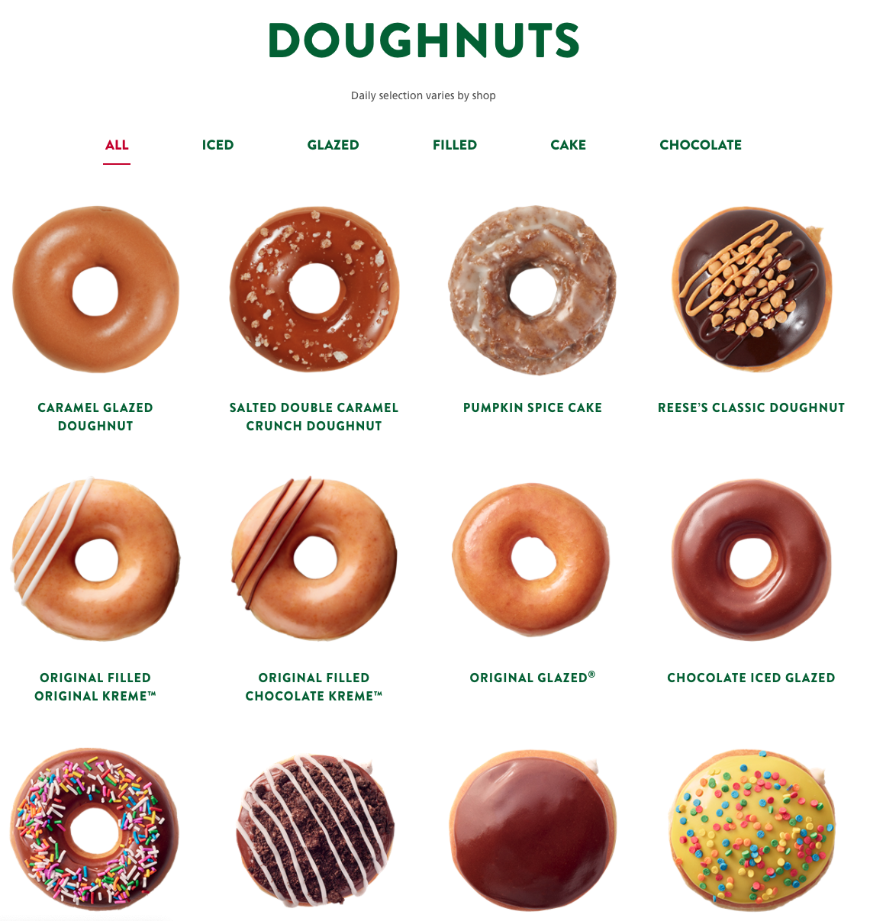

Requirements
Serverless and Function as a Service (aka Lambda)
Required for an A (93/100 points):
- S3 is used on the front end for the web assets (10 points)
- The application will leverage Lambda to run one or more functions (20 points)
- The application will leverage API Gateway to send data to/from Lambda (20)
- The application will leverage DynamoDB as a database (20)
- Create a yearly price estimate for running your infrastructure if this were production (explain your traffic assumptions—see the Frequently asked questions below) (10 points)
- AWS Infrastructure Diagram of your prototype (5 points)
- AWS Infrastructure Diagram for a region if this were production (5 points)
- Looks Professional (3 points)

Recommendations and Additional Options:

- S3 bucket may optionally be supported by CloudFront to distribute web assets (.25 points). Est. 5 min.
- IaC: Use SAM (an extension of CloudFormation), CDK, Terraform, or CloudFormation to create and update your infrastructure (2 points). Est. 3-5 hours.
- Use a Code Pipeline (any provider that you wish) (2 points). Est. 1-2 hours.
- A language other than Node is used for the application (2). Est. up to 5 hours.
- A real URL is registered for use with S3 or CloudFront (.5). Est up to 1 hour.
- Any other infrastructure enhancements that you see fit are allowed (e.g. database caching services)

Rubric

100 points maximum are possible for this project, as follows:

Project Features
S3 used to host web assets | /10
Lambda runs one or more functions | /20
API Gateway used to trigger Lambda functions | /20
DynamoDB for database | /20
AWS Infrastructure Diagram of your prototype | /5
AWS Infrastructure Diagram of a region if this were production | /5
Yearly price estimate for global deployment of your application in production | /10
Looks professional | /3
OPTIONAL FEATURES
CloudFront used | /.25
IaC used to build/maintain infrastructure | /2
A Code Pipeline supports the application | /2
Used programming language other than that shown in labs | /2
A real URL is used with S3 or CloudFront | /.5
Other enhancements | TBD
Total | /100 (max)

Deliverables

To demonstrate completion of your project, fill out the Serverless Project submission document and then submit it to the Learning Management System.

Tips

- You should be able to do the required portion of the project quickly with no more than 2-3 hours per person based on the tutorials you have been provided in class. Understand that additional features such as a code pipeline or IaC, which are critical to modern software development and required by any employer, could easily add 10 hours of work for a given individual. If you just want the basic points for this project, don’t bite off more than you can chew.

- I am happy to have you share resources in a shared document that can be seen by all groups.

https://docs.google.com/document/d/15nGDiROsN5hghWSiLfJNPo-khmE1TTe2QZYlAEhJXrE/edit?usp=sharing

Feel free to add new links and sections and provide a brief explanation of why the tutorial or resource is helpful. Keep in mind that any service found in AWS has a great documentation page AND a tutorials subsection within that documentation. Some links have already been added for API Gateway, Lambda.

- You can discuss your projects in slack liberally.

Frequently Asked Questions

What should be in the prototype diagram? The diagram should be based on the prototype that you create for this project. Don’t put things in the diagram that you didn’t build into your infrastructure for the project, such as caching services, advanced firewalls.

What should be in the production diagram? Diagram what the solution would be if you were supporting a region that supports a company the size of Starbucks or McDonalds.

How do I do a global price estimate for one year? 1. List out each service from your production diagram related to a single region. 2. Use the AWS online pricing calculator to estimate each service in your production diagram (services, bandwidth/data transfer costs [which can be significant]). 3. Make assumptions about the level of traffic you will get. You get to make it up, but it has to be logical. For example, McDonalds has users of its app, but does every customer use the app? Is it 1%, 10%, 90%? How much bandwidth does each customer use when using an app? At the end of the day, you might do something like this: 100 million annual purchases, 1% of those access the application, each access uses 8K of data transfer, that traffic is equally divided among 10 regions.

